Store your XML documents in a table with two columns

1. An identifier to act as a PK for each laptop document (e.g., laptopno), and also create a sequence to supply values for this identifier.
2. your xml laptop document as the other column.
3. The storage must be managed via a registered schema. You are required to use Binary XML storage for the XML component. Ensure you explicitly declare this, do not leave it to the Oracle defaults.

Provide the SQL commands which you used to store your data.

1. Register the Schema into Oracle (1.sql)

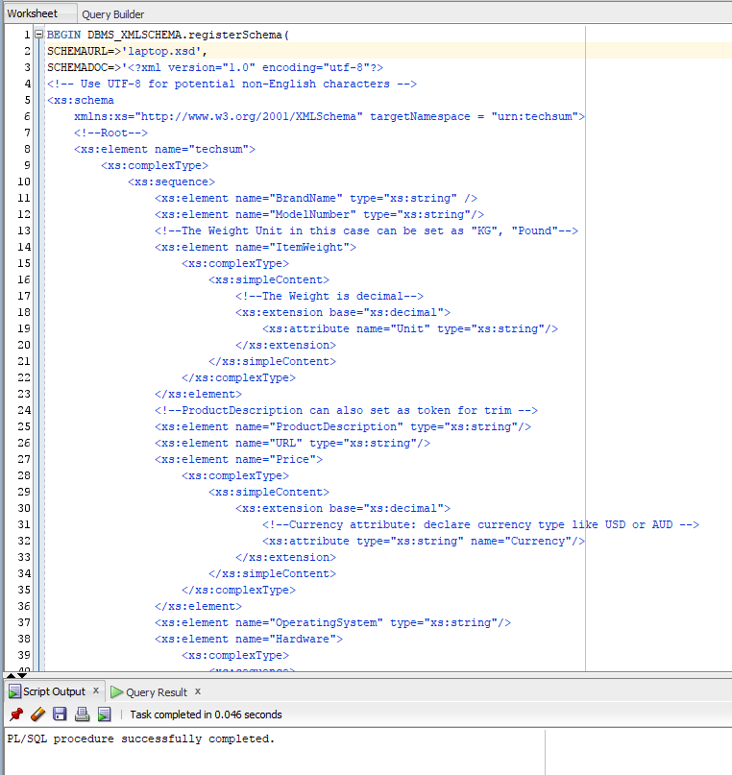

1. Create Table (2.sql)

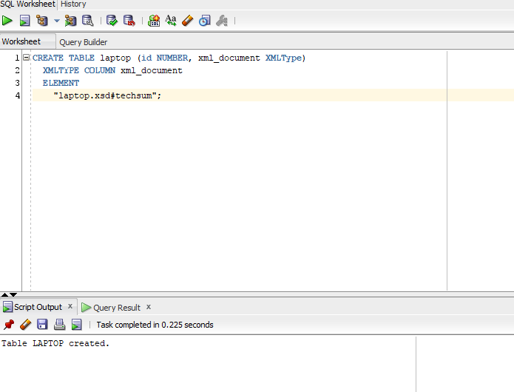

1. Insert Record (3.sql)

